
Name of Student: [MBUI ALLAN FABIAN]
Admission No.: [CIS-0-1403-3/2019]
Name of Supervisor: [___________________]

Submitted by [MBUI ALLAN FABIAN] to Kenya Methodist University, in partial fulfillment of the requirements for the degree of Bachelor of Science in Computer Information Systems.
[DATE:_____________________________________________________]

CISY 401: Research Project I
Title of Research: Design and Implementation of a Web-Based Student Management System for Efficient Academic Record Keeping

Declaration by the Candidate
This research project, which is my original work, has not been presented for a degree in any other University. No part of this research may be reproduced without the prior permission of the author and/or KEMU.

Name of candidate: MBUI ALLAN FABIAN
Date:__________________________ Signature:______________________________
Computer and Information Science Department
Kenya Methodist University

Declaration by the Supervisor(s)
This research project has been submitted for examination with our approval as University Supervisors.
Name of the Supervisor: [___________________________________]
Signature: ___________________________ Date: _______________________
Department: ___________________________________________________________

Acknowledgments
To God, the source of all knowledge and perseverance: thank you for the health, strength, and opportunity to pursue this research. This achievement is a testament to Your providence.

I am also grateful to the faculty of the Department of Information and Technology at KeMU for providing the resources and environment necessary to complete this work. To my colleagues and peers, thank you for the late-night brainstorming sessions and for making the lab feel like home.

A special thanks goes to my friends and family.
Thank you for the endless coffee and for listening to me vent about data for hours on end. Thank you for your love and for keeping me grounded when the deadlines felt impossible."

Abstract

Problem statement
The management of student academic records is a critical function in educational institutions; however, relying on manual, paper-based, or fragmented spreadsheet systems often leads to data redundancy, calculation errors, and delays in information retrieval. This research project aimed to design and implement a secure, Web-Based Student Management System (SMS) to automate the recording and processing of student grades.

Objectives
The primary objective was to develop a centralized database system capable of securely storing student profiles, managing departmental courses, and automatically calculating Weighted Grade Point Averages (GPA) in real-time.

Methodology
The methodology adopted for this project was the Agile software development lifecycle, utilizing a relational database model. The backend was developed using PHP and MySQL to ensure robust data handling and enforce referential integrity, while the frontend utilized HTML, CSS, and JavaScript for an intuitive user interface. The resulting system successfully demonstrates a working prototype featuring distinct access levels: an Administrator portal for full CRUD (Create, Read, Update, Delete) operations on students, courses, and grades, and a Read-Only Student portal for secure transcript viewing. The implementation of this system concludes that transitioning from manual record-keeping to a web-based relational database significantly improves data accuracy, eliminates GPA calculation errors, and provides stakeholders with instantaneous access to academic performance metrics.

Table of Contents
Declaration by the Candidate 1
Declaration by the Supervisor(s) 1
Acknowledgments 2
Abstract 3
Problem statement 3
Objectives 3
Methodology 3
Dedication 6
List of Abbreviations 7
CHAPTER ONE: INTRODUCTION 8
1.1 Background to the Study 8
1.2 Statement of the Problem 8
1.3 Objectives of the Study 9
General Objective: 9
Specific Objectives: 9
1.4 Justification 9
1.5 Hypothesis 9
1.6 Area and Scope of the Study 10
CHAPTER TWO: LITERATURE REVIEW 11
2.1 Introduction 11
2.2 Evolution of Student Records Management 11
2.3 Review of Existing Systems 11
2.4 The Identified Gap 12
2.5 Conceptual Framework 12
CHAPTER THREE: METHODOLOGY 13
3.1 Introduction 13
3.2 Choice of Methodology 13
3.3 Suitability of Methodology 13
3.4 Application of Methodology and System Design 14
3.4.1 System Architecture 14
3.4.2 Relational Database Design 14
3.5 Use of Mathematical Models 15
3.6 Computer Technology Used 15
CHAPTER FOUR: RESULTS 16
4.1 Introduction 16
4.2 User Authentication and Access Control 16
4.3 Administrator Dashboard and Student Management 17
4.4 Department and Course Management 17
4.5 Automated Grade Processing 18
4.6 The Student Portal 19
CHAPTER FIVE: CONCLUSION AND RECOMMENDATION 20
5.1 Introduction 20
5.2 Conclusion 20
5.3 Recommendations 20

Dedication
I dedicate this project to my parents, for their unwavering support and belief in my potential and for their endless support and encouragement throughout my academic journey.
And to the version of me who started this project, and the version of me who refused to give up on it.

List of Abbreviations

CRUD: Create, Read, Update, Delete

CSS: Cascading Style Sheets

GPA: Grade Point Average

HTML: HyperText Markup Language

KEMU: Kenya Methodist University

PHP: PHP: Hypertext Preprocessor

RDBMS: Relational Database Management System

SMS: Student Management System

SQL: Structured Query Language

CHAPTER ONE: INTRODUCTION

1.1 Background to the Study
In the modern educational landscape, the accurate and timely management of student data is vital for institutional success. Historically, educational institutions have relied on manual ledger books, filing cabinets, and standalone spreadsheet software to track student enrollment, departmental courses, and academic grading. While these traditional methods were sufficient for smaller populations, the rapid expansion of student enrollments and the increasing complexity of academic curriculums have rendered them inefficient. The advent of web-based technologies and Relational Database Management Systems (RDBMS) has provided a framework to digitize these processes. A Web-Based Student Management System (SMS) centralizes academic data, allowing administrators to efficiently manage records while empowering students to track their academic progression securely and in real-time.

1.2 Statement of the Problem
Many academic departments still struggle with fragmented data management systems. When student details, course enrollments, and academic grades are handled manually or across disconnected files, it leads to significant inefficiencies. These include human errors during manual Grade Point Average (GPA) calculations, high risks of data loss, unauthorized access to sensitive academic records, and prolonged delays for students waiting for their transcripts. There is a critical need for a centralized, automated system that enforces data integrity and streamlines the grading process.

1.3 Objectives of the Study

General Objective:
To design and develop a Web-Based Student Management System that automates the recording, processing, and viewing of academic grades.

Specific Objectives:
- To design a secure relational database (MySQL) for storing student profiles, departments, courses, and examination grades.
- To develop an Administrator dashboard (PHP) capable of performing CRUD operations and managing academic records.
- To implement an automated calculation engine that computes student Weighted GPAs based on course credits and scored marks.
- To create a secure Student Portal that allows learners to view their academic transcripts and overall performance in real-time.

1.4 Justification
The implementation of this system will highly benefit academic administrators by drastically reducing the administrative burden and eliminating mathematical errors in grade calculations. For the students, it provides immediate, transparent access to their academic standing. Furthermore, the system enforces data security through role-based access control (Admin vs. Student), ensuring that sensitive educational records are protected against unauthorized modifications.

1.5 Hypothesis

H1: The implementation of a web-based Student Management System will significantly reduce the time required to process and publish student grades compared to manual methods.

H2: Automating GPA calculations through a centralized database will eliminate human calculation errors in student transcripts.

1.6 Area and Scope of the Study
This study focuses on the development of a core academic tracking prototype. The scope is limited to user authentication, departmental and course management, student registration, grade entry, and the automated generation of a student transcript with GPA calculation. It does not currently cover financial modules (fee processing), library management, or human resource payroll systems.

CHAPTER TWO: LITERATURE REVIEW
2.1 Introduction
This chapter reviews existing literature and case studies related to Student Management Systems (SMS) and academic record-keeping. It explores the evolution of data management in educational institutions, analyzes the strengths and weaknesses of current software solutions, and identifies the gaps that the proposed Web-Based Student Management System seeks to address.
2.2 Evolution of Student Records Management
Historically, educational institutions managed student data using manual, paper-based filing systems. While this approach was feasible for small student populations, it proved highly inefficient as institutions grew. Manual systems are characterized by physical storage limitations, high susceptibility to data loss through physical damage, and significant delays in data retrieval.
With the advent of personal computing, institutions transitioned to standalone desktop applications, often utilizing spreadsheet software like Microsoft Excel or localized database tools like Microsoft Access. While these desktop solutions improved calculation speeds and reduced physical paper trails, they introduced new challenges. Standalone systems lack remote accessibility, suffer from data silos (where different departments have conflicting versions of the same spreadsheet), and pose severe security risks if the host computer crashes or is compromised.
2.3 Review of Existing Systems
The current technological standard involves Enterprise Resource Planning (ERP) systems and comprehensive web-based solutions. Systems such as Oracle Student Cloud, Blackboard, and SAP Student Lifecycle Management offer vast arrays of features.
- Strengths: These enterprise systems provide robust data analytics, cloud backups, and high-level security. They integrate various institutional branches, including human resources, finance, and library management, into one ecosystem.
- Weaknesses: The primary drawback of these enterprise solutions is their immense cost and complexity. They require significant financial investment for licensing, extensive hardware infrastructure, and specialized IT personnel for maintenance. For smaller institutions or specific academic departments, these systems suffer from "feature bloat"—providing overwhelming modules that the department neither needs nor uses.
2.4 The Identified Gap
Based on the review of existing solutions, a significant gap exists for lightweight, highly focused, and cost-effective web-based systems. Many academic departments do not require multi-million-shilling ERP software; they simply need a secure, reliable way to manage student profiles, assign courses, and automate grading.
The proposed system addresses this gap by utilizing open-source technologies (PHP and MySQL) to deliver a streamlined, browser-based solution. It strips away the unnecessary complexity of enterprise software, focusing purely on the core CRUD (Create, Read, Update, Delete) operations required for academic record-keeping. By ensuring the system is web-based, it solves the accessibility issue of legacy desktop apps, allowing administrators and students to access real-time data from any device with an internet connection.
2.5 Conceptual Framework
The proposed system operates on a straightforward Input-Process-Output (IPO) model:
- Input: System administrators input primary data, including departmental details, course codes and credit weights, student personal information, and raw examination scores.
- Process: The system's backend, driven by PHP, processes this data. It validates user inputs, enforces relational database constraints (such as preventing the deletion of a department that has active students), and utilizes mathematical algorithms to convert raw scores into standardized letter grades and Weighted Grade Point Averages (GPA).
- Output: The processed data is securely rendered to the frontend interface. Administrators receive comprehensive, sortable lists of student cohorts and grade books. Students receive a dynamically generated, read-only academic transcript detailing their performance and overall GPA.

CHAPTER THREE: METHODOLOGY
3.1 Introduction
This chapter outlines the research methodology and system development life cycle applied in the creation of the Web-Based Student Management System. It details the choice and suitability of the methodology, the architectural design, the mathematical models used for grade computation, and the specific computer technologies utilized during implementation.
3.2 Choice of Methodology
The methodology selected for this project was the Agile Software Development Life Cycle, specifically utilizing a rapid prototyping approach. Agile methodology focuses on iterative development, where requirements and solutions evolve through collaborative effort and continuous testing. Instead of attempting to build the entire system at once, the project was broken down into manageable, functional modules: user authentication, database architecture setup, departmental routing, student registration (CRUD operations), and finally, the grade calculation engine.
3.3 Suitability of Methodology
The Agile methodology was highly suitable for this academic project for several reasons. First, it allowed for the immediate testing of individual components—such as verifying that a database query successfully added a student before moving on to building the interface to display that student. Second, web development often requires rapid adjustments; when user interface components (such as dropdown menus or responsive layouts) did not behave as expected, the iterative nature of Agile allowed for immediate code refactoring without disrupting the entire system architecture. Finally, it facilitated the continuous refinement of the relational database constraints, ensuring strict data integrity.

3.4 Application of Methodology and System Design
The application of the methodology involved a structured approach to system analysis and database design.
3.4.1 System Architecture
The project utilizes a standard Client-Server architecture. The frontend (Client) acts as the presentation layer where users (Administrators and Students) interact with the system via a web browser. The backend (Server) processes business logic, handles security (session management and access control), and executes database queries.
3.4.2 Relational Database Design
The core of the application relies on a Relational Database Management System (RDBMS). The database schema was designed to enforce referential integrity using Primary Keys and Foreign Keys.
- Departments Table: Stores department IDs and names.
- Courses Table: Linked to departments, storing course codes, names, and credit weights.
- Students Table: Stores user credentials and personal details, linked to the departments table to ensure each student belongs to a valid department.
- Grades Table: Acts as a junction table resolving the many-to-many relationship between students and courses. It utilizes ON DELETE CASCADE constraints, ensuring that if a student or course is removed from the system, all associated orphaned grade data is automatically purged, maintaining a clean database.

3.5 Use of Mathematical Models
To fulfill the requirement for automated academic processing, the system employs mathematical models to compute letter grades. The backend algorithms calculate grades using the following conditional logic model:
- If Score ≥ 80%, Grade = A
- If 79% ≤ Score < 75%, Grade = B+
- If 74% ≤ Score < 70%, Grade = B
- If 69% ≤ Score < 65%, Grade = C+
- If 64% ≤ Score < 60%, Grade = C
- If 59% ≤ Score < 55%, Grade = D+
- If 54% ≤ Score < 50%, Grade = D
- If Score < 50%, Grade = F
Furthermore, a Weighted Grade Point Average (GPA) algorithm is applied, where the formula computes the sum of the products of the course credits and grade points, divided by the total attempted credits: GPA = Σ(Credit_i × GradePoint_i) / Σ(Credit_i).)
3.6 Computer Technology Used
The development of the system relied on a robust stack of modern web technologies:
- Backend: PHP (Hypertext Preprocessor) was used for server-side scripting, handling form submissions, algorithmic calculations, and database connections.
- Database: MySQL was utilized as the database engine, managed via phpMyAdmin on a local XAMPP server environment.
- Frontend: HTML5 and CSS3 were used to structure and style the user interface.
- JavaScript was implemented for real-time client-side interactions, such as auto-calculating grade letters before form submission and triggering visual success banners.

CHAPTER FOUR: RESULTS
4.1 Introduction
This chapter presents the outcomes of the system implementation. The Web-Based Student Management System was successfully developed, tested, and deployed in a local server environment (XAMPP). The results demonstrate that the system meets the core objectives outlined in Chapter One, specifically providing secure access control, robust database management for academic records, and automated grade calculations.
4.2 User Authentication and Access Control
The system successfully implements role-based access control. Upon accessing the application, users are presented with a secure login interface. The backend PHP logic securely verifies credentials against the MySQL database and routes the user to their respective dashboard based on their assigned role (Administrator or Student). This ensures that sensitive CRUD operations are restricted strictly to authorized personnel.
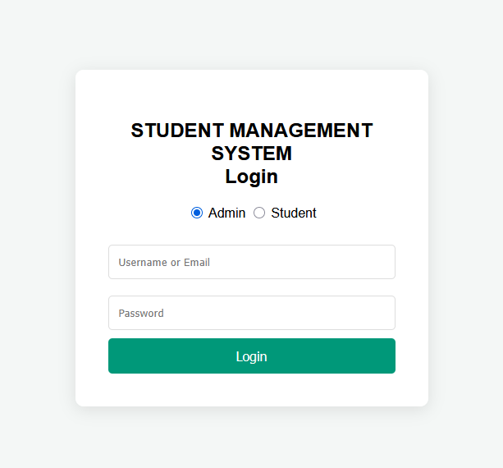
Figure 4.1: System Login Interface
4.3 Administrator Dashboard and Student Management
The Administrator portal serves as the central hub for data management. The system successfully executes Create, Read, Update, and Delete (CRUD) operations for student records. Administrators can seamlessly register new students, assign them to specific academic departments, and modify their details.
A key result in the user interface design is the implementation of dynamic feedback banners. When an administrator adds, edits, or deletes a student, the system captures the status via URL parameters and displays a context-aware success or error message, which automatically dismisses after three seconds.
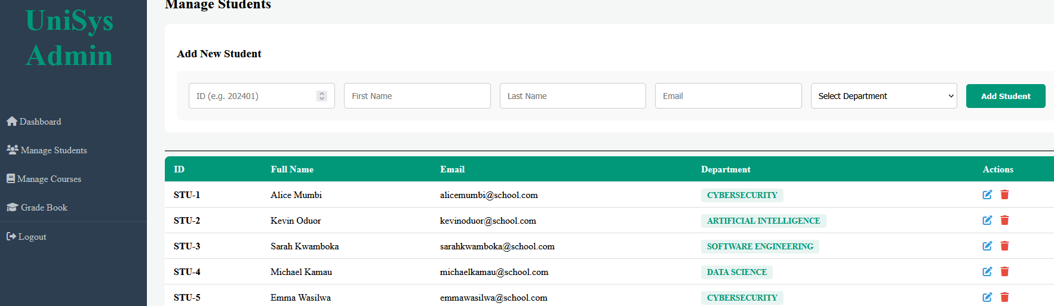Figure 4.2: Administrator Dashboard displaying Student Records
4.4 Department and Course Management
The system successfully maintains referential integrity between departments and courses. Administrators can add new courses, define their credit weights, and link them to specific departments. The dropdown menus in the system dynamically populate from the database, ensuring that data entry remains consistent and typographical errors are eliminated.
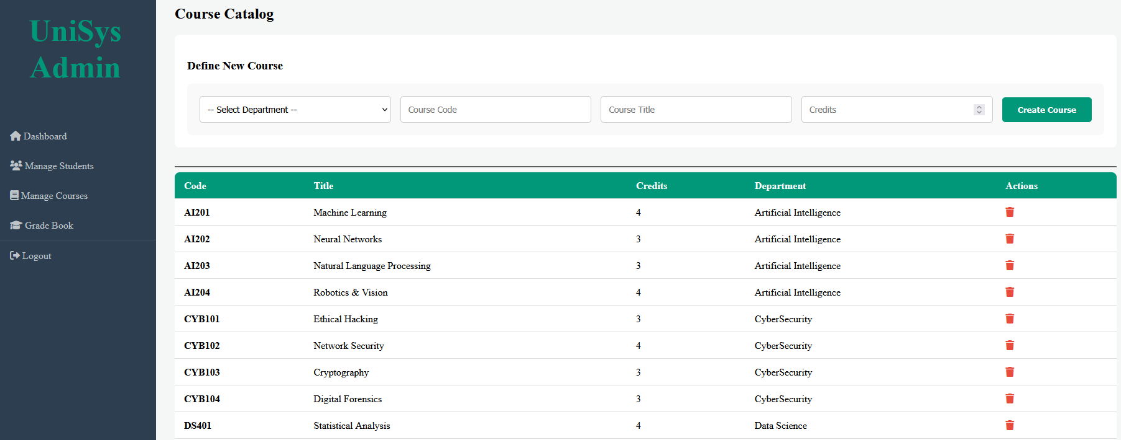Figure 4.3: Course Management interface showing relational data linking courses to departments.
4.5 Automated Grade Processing
One of the primary objectives of this project was the automation of academic grading. The Grade Book module allows administrators to select a student and a course, and input a raw score.
The results show a two-tier calculation process:
- Frontend Real-Time Calculation: As the administrator types the score, a JavaScript function immediately calculates and displays the corresponding letter grade (A, B, C, D, or F) and applies color-coding for visual feedback.
- Backend Verification: Upon submission, the PHP backend recalculates the grade to prevent client-side manipulation before securely committing the record to the database. The system successfully prevents data redundancy and handles cascading deletions if a course or student is removed.
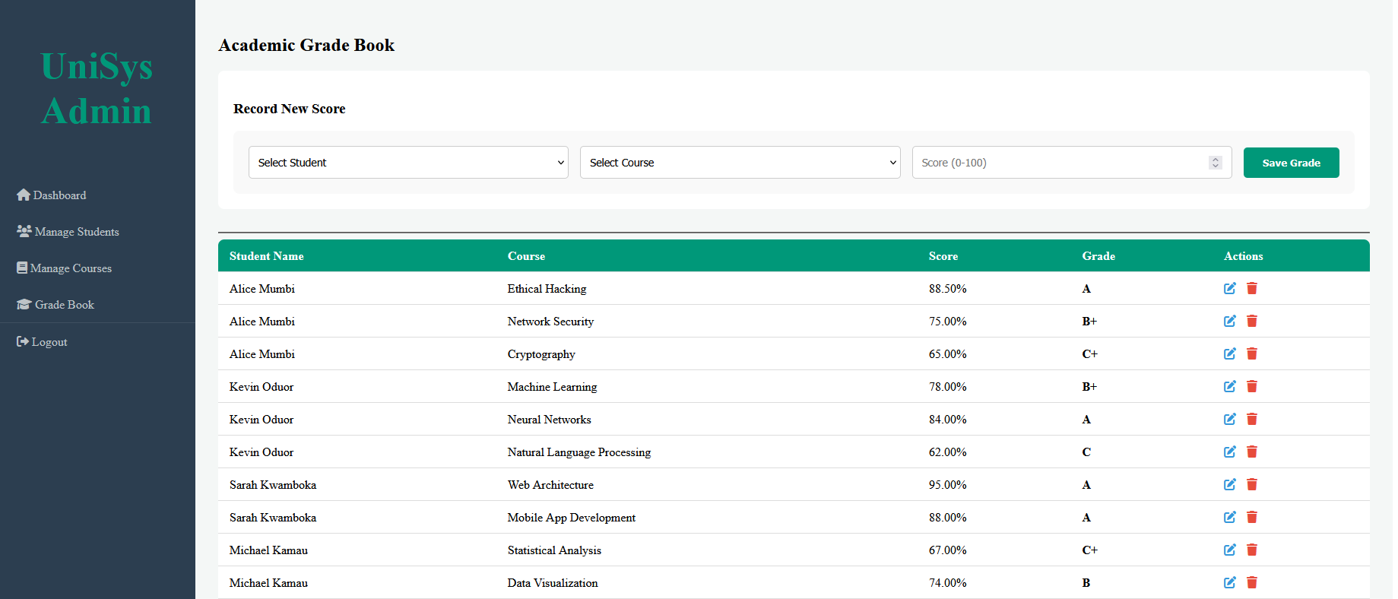Figure 4.4: Grade Book Interface demonstrating real-time automated grade calculation.
4.6 The Student Portal
The system successfully provides a secure, read-only interface for students. When a student logs in, the system uses their session ID to retrieve and display only their specific academic records. The student can view their enrolled courses, individual scores, and final letter grades in a formatted transcript view, fulfilling the objective of providing immediate and transparent academic tracking.
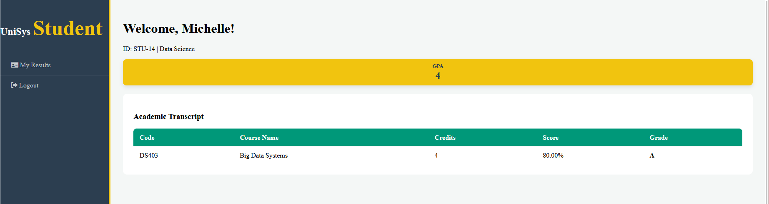Figure 4.5: Student Portal displaying the read-only academic transcript.

CHAPTER FIVE: CONCLUSION AND RECOMMENDATION
5.1 Introduction
This final chapter summarizes the findings of the research project and provides a conclusion based on the implementation of the Web-Based Student Management System. It also offers recommendations for institutional adoption and suggestions for future enhancements to the system.
5.2 Conclusion
The primary objective of this research project was to design and implement a Web-Based Student Management System to replace inefficient, manual academic record-keeping processes. Through the application of the Agile methodology, a robust relational database was developed using MySQL, and a dynamic user interface was created using PHP, HTML, CSS, and JavaScript.
The successful deployment of the prototype demonstrates that transitioning to an automated, web-based platform significantly mitigates the risks associated with manual data entry. By implementing role-based access control, the system ensures that only authorized administrators can modify sensitive academic records, thereby enhancing data security. Furthermore, the integration of algorithmic calculations directly into the application logic successfully eliminates human error in the computation of student grades and Grade Point Averages (GPA). Ultimately, the project proves that a lightweight, strictly focused CRUD application can provide administrators and students with immediate, accurate, and transparent access to academic performance metrics.
5.3 Recommendations
Based on the successful development and testing of this prototype, the following recommendations are made for both immediate adoption and future academic research:
- Institutional Implementation: It is recommended that academic departments currently relying on fragmented spreadsheet software transition to this centralized database model. Training sessions should be conducted for administrators to familiarize them with the automated grading and reporting interfaces.
- Cloud Deployment: While the current system operates efficiently in a local server environment (XAMPP), it is highly recommended to deploy the database and PHP codebase to a secure cloud-hosting platform. This will ensure 24/7 accessibility for students and staff from any geographic location.
- Future System Enhancements: Future iterations of this project should expand the system's scope by integrating additional modules. Recommended additions include:
  - A Financial Module: To track student fee payments and automatically restrict transcript access for students with outstanding balances.
  - Automated Notifications: Integrating an SMS or Email API to automatically notify students when new grades have been posted to their portal.
  - Data Analytics Dashboard: Developing a visual analytics module using chart libraries to help department heads track overall course performance and pass/fail trends over multiple semesters.

REFERENCES
Connolly, T., & Begg, C. (2015). Database Systems: A Practical Approach to Design, Implementation, and Management (6th ed.). Pearson.

Nixon, R. (2021). Learning PHP, MySQL & JavaScript: With jQuery, CSS & HTML5 (6th ed.). O'Reilly Media.

Pressman, R. S., & Maxim, B. R. (2019). Software Engineering: A Practitioner's Approach (9th ed.). McGraw-Hill Education.

Sommerville, I. (2015). Software Engineering (10th ed.). Pearson.

Valacich, J., & George, J. (2020). Modern Systems Analysis and Design (9th ed.). Pearson.

